**Assessment**

**Pet Classification Model Using CNN**

DESCRIPTION

**Project Objective:**

Build a CNN model that classifies the given pet images correctly into dog and cat images.   
The project scope document specifies the requirements for the project “Pet Classification Model Using CNN.” Apart from specifying the functional and non-functional requirements for the project, it also serves as an input for project scoping.

**Project Description and Scope:**

You are provided with a collection of images of pets, that is, cats and dogs. These images are of different sizes with varied lighting conditions and they should be used as inputs for your model.

You are expected to write the code for CNN image classification model using TensorFlow that trains on the data and calculates the accuracy score on the test data.

**Project Guidelines:**

Begin by creating the ipynb file in the same parent folder where the downloaded data set is kept. The CNN model should have the following layers:   
● Input layer   
● Convolutional layer 1 with 32 filters of kernel size[5,5]   
● Pooling layer 1 with pool size[2,2] and stride 2   
● Convolutional layer 2 with 64 filters of kernel size[5,5]   
● Pooling layer 2 with pool size[2,2] and stride 2   
● Dense layer whose output size is fixed in the hyper parameter: fc_size=32   
● Dropout layer with dropout probability 0.4   
Predict the class by doing a softmax on the output of the dropout layers.   
This should be followed by training and evaluation:   
● For the training step, define the loss function and minimize it   
● For the evaluation step, calculate the accuracy   
Run the program for 100, 200, and 300 iterations, respectively. Follow this by a report on the final accuracy and loss on the evaluation data.

**Sample Data**

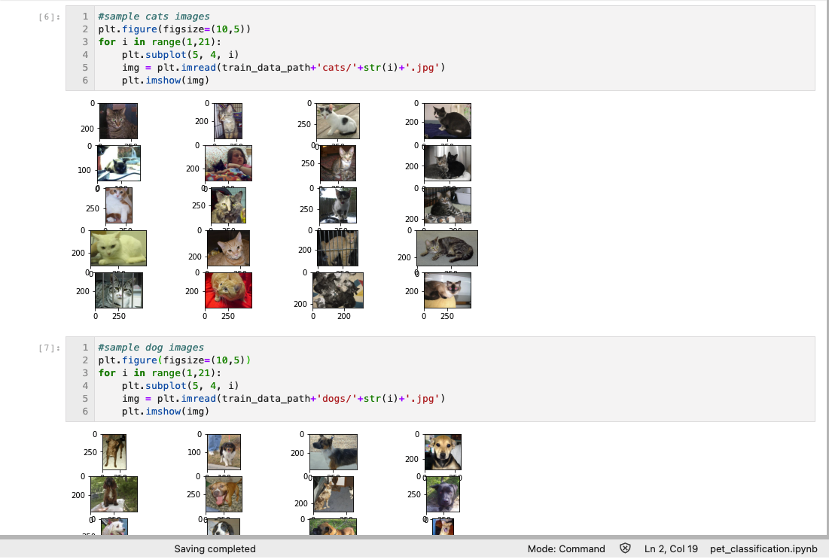

Provided data consists of only 20 images of cats and dogs each for training and 10 images each for testing/validation.

**Data Augmentation**

As the data is very low, we need to perform Data Augmentation.

Data augmentation is a technique to artificially create new training data from existing training data.

In this project augmentation technique used are

* Rescale
* Rotation
* Shear Transformation
* Zoom
* Height and Width Shift
* Brightness

Sample Results of Data Augmentation using Tensorflow Keras API ImageDataGenerator

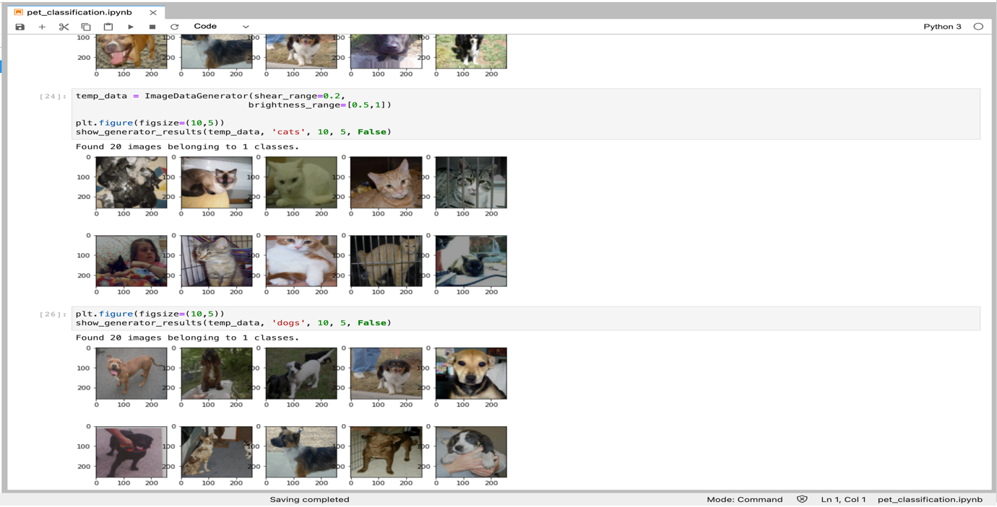

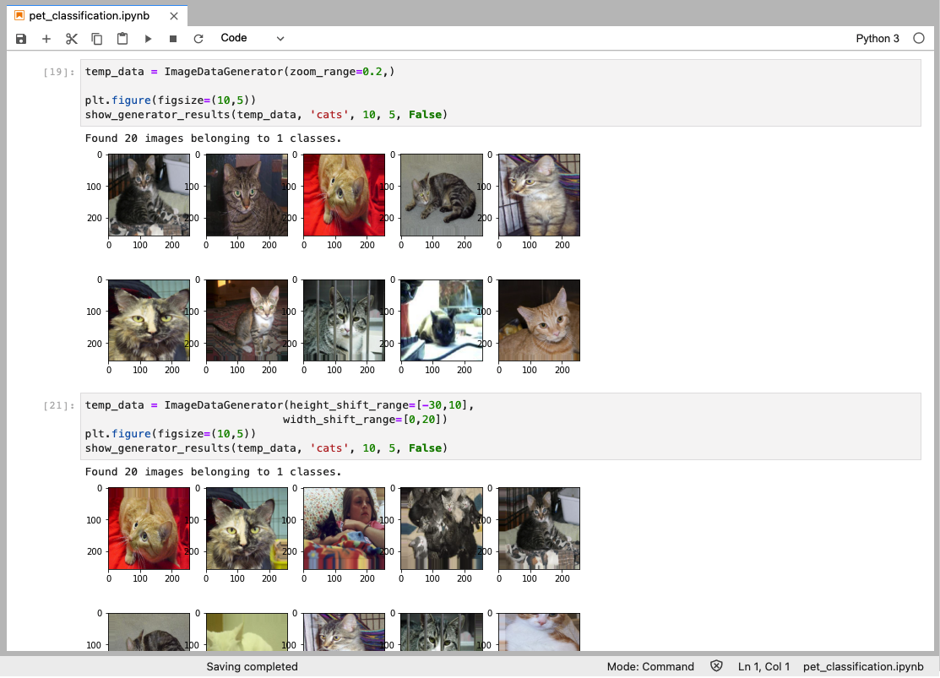

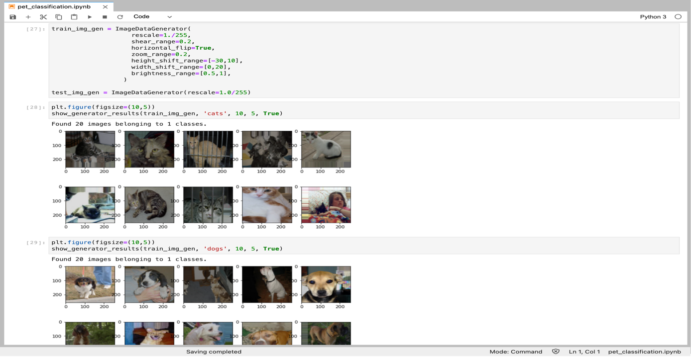

**Model Building**

As mentioned in the project guidelines, Model consists of 2 convolution layers with kernel size as 5x5 and filters 32 and 64 respectively. Each convolution layer is followed by a activation function ‘relu’ and max_pooling layer with filter size as 2x2 and strides as 2.

After 2nd Pooling layer image is flatten and passed to Fully connected 32 neurons.

Output layer consists of 2 neurons with activation function as ‘softmax’ which outputs the probability of each class i.e cat and dog.

**Model Summary**

Model: "sequential"

_________________________________________________________________

Layer (type) Output Shape Param #

=================================================================

conv2d (Conv2D) (None, 220, 220, 32) 2432

_________________________________________________________________

max_pooling2d (MaxPooling2D) (None, 110, 110, 32) 0

_________________________________________________________________

conv2d_1 (Conv2D) (None, 106, 106, 64) 51264

_________________________________________________________________

max_pooling2d_1 (MaxPooling2 (None, 53, 53, 64) 0

_________________________________________________________________

flatten (Flatten) (None, 179776) 0

_________________________________________________________________

dense (Dense) (None, 32) 5752864

_________________________________________________________________

dropout (Dropout) (None, 32) 0

_________________________________________________________________

dense_1 (Dense) (None, 2) 66

=================================================================

Total params: 5,806,626

Trainable params: 5,806,626

Non-trainable params: 0

_________________________________________________________________

**Model Training and Evaluation**

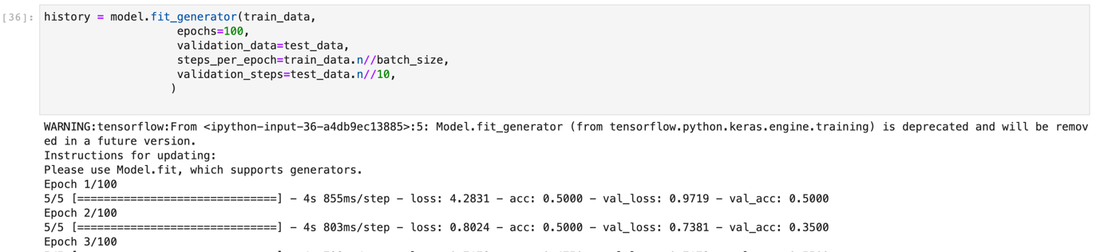



**Conclusion**

Model is trained for 100, 200 and 300 epochs and evaluation results are as follow,

|  |  |  |  |
| --- | --- | --- | --- |
| Number of Epochs | 100 | 200 | 300 |
| Accuracy | 40% | 51% | 60% |